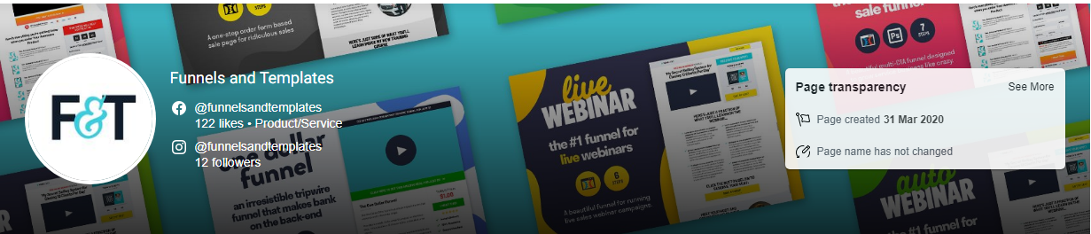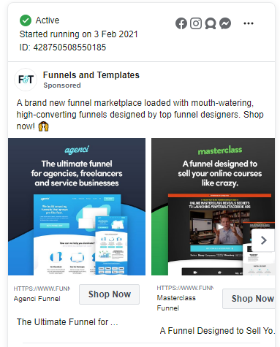

(<https://www.funnelsandtemplates.com/?fbclid=IwAR2_s4X24zSY7QuAm_1EZ_lsuOckMmsP46lQp9q2QmzbCB8zVLc4NOfXupw>)

(<https://www.funnelsandtemplates.net/join-now>)

(<https://www.facebook.com/ads/library/?active_status=all&ad_type=political_and_issue_ads&country=IN&id=428750508550185&view_all_page_id=101920838137219>)

(<https://www.facebook.com/ads/library/?active_status=all&ad_type=political_and_issue_ads&country=IN&id=425013288898971&view_all_page_id=101920838137219>)

**FlashSale**

**$47**

**The perfect funnel for running successful Sale promotions.**

(<https://www.funnelsandtemplates.com/flash-sale-clickfunnels-template/?fbclid=IwAR2o1zbTHaHcExjtDnkNwnrhdn_QP1wVuKahUBZPt3-yc9so2lHAJ4d9a-w>)

(<https://www.funnelsandtemplates.com/agenci-clickfunnels-template/?fbclid=IwAR0FDvbG3yyLv_HnV7J-mzihEjPv3ZMYtOB_26o2zKzsolImmvQU1IHSeJU>)

(<https://www.funnelsandtemplates.com/masterclass-clickfunnels-template/?fbclid=IwAR1CdQXgxspzkjpNwdE2Et4hKjTOIGrwBXVb4jnfBzmbAyP5qZA30hPHriY>)

(<https://www.funnelsandtemplates.com/10-free-clickfunnels-squeeze-page-templates/?fbclid=IwAR0FDvbG3yyLv_HnV7J-mzihEjPv3ZMYtOB_26o2zKzsolImmvQU1IHSeJU>)

(<https://www.funnelsandtemplates.com/one-dollar-funnel/?fbclid=IwAR1u73Lg1Ojw_Ck0fmALHfpsxXM89NV_i4Voe9XZLkAX90gUJ8F3A-xTRcU>)

(<https://www.funnelsandtemplates.com/one-page-clickfunnels-funnel/?fbclid=IwAR0FDvbG3yyLv_HnV7J-mzihEjPv3ZMYtOB_26o2zKzsolImmvQU1IHSeJU>)

**Best-selling ClickFunnels templates**

(<https://www.funnelsandtemplates.com/?fbclid=IwAR0x_G4ifOXv9MSfo_ZkOaoZ9n5K76lKU56AozBfLQMhMPOFqbGbQi9F_is>)